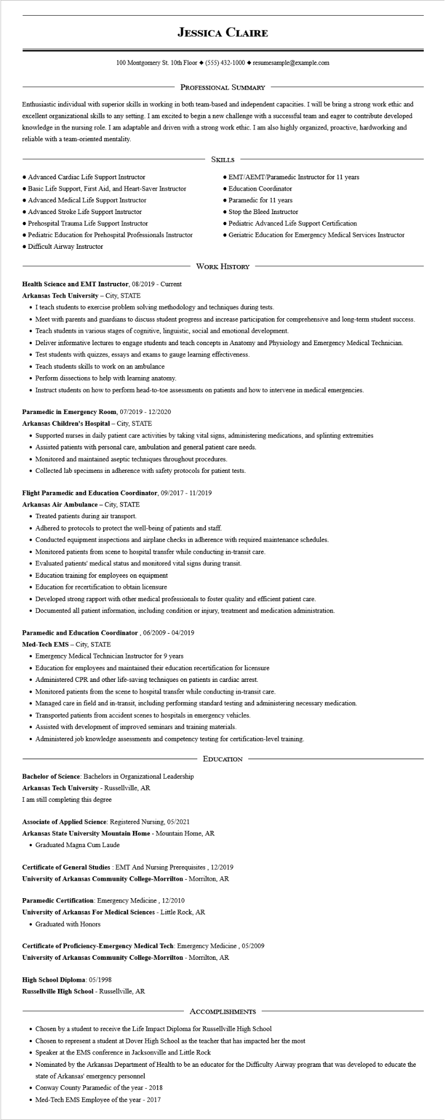
JESSICA CLAIRE
100 Montgomery St. 10th Floor (555) 432-1000◆ resumesample@example.com
PROFESSIONAL SUMMARY
Enthusiastic individual with superior skills in working in both team-based and independent capacities. I will be bring a strong work ethic and excellent organizational skills to any setting. I am excited to begin a new challenge with a successful team and eager to contribute developed knowledge in the nursing role. I am adaptable and driven with a strong work ethic. I am also highly organized, proactive, hardworking and reliable with a team-oriented mentality.
• Advanced Cardiac Life Support Instructor
• Basic Life Support, First Aid, and Heart-Saver Instructor
• Advanced Medical Life Support Instructor
• Advanced Stroke Life Support Instructor
• Prehospital Trauma Life Support Instructor
• Pediatric Education for Prehospital Professionals Instructor • Difficult Airway Instructor
SKILLS
• EMT/AEMT/Paramedic Instructor for 11 years
• Education Coordinator
• Paramedic for 11 years
• Stop the Bleed Instructor
• Pediatric Advanced Life Support Certification
• Geriatric Education for Emergency Medical Services Instructor
Health Science and EMT Instructor, 08/2019 - Current Arkansas Tech University - City, STATE
WORK HISTORY
• I teach students to exercise problem solving methodology and techniques during tests.
• Meet with parents and guardians to discuss student progress and increase participation for comprehensive and long-term student success.
• Teach students in various stages of cognitive, linguistic, social and emotional development.
• Deliver informative lectures to engage students and teach concepts in Anatomy and Physiology and Emergency Medical Technician.
• Test students with quizzes, essays and exams to gauge learning effectiveness.
• Teach students skills to work on an ambulance
• Perform dissections to help with learning anatomy.
• Instruct students on how to perform head-to-toe assessments on patients and how to intervene in medical emergencies.
Paramedic in Emergency Room, 07/2019 - 12/2020
Arkansas Children's Hospital - City, STATE
• Supported nurses in daily patient care activities by taking vital signs, administering medications, and splinting extremities
• Assisted patients with personal care, ambulation and general patient care needs.
• Monitored and maintained aseptic techniques throughout procedures.
• Collected lab specimens in adherence with safety protocols for patient tests.
Flight Paramedic and Education Coordinator, 09/2017 - 11/2019
Arkansas Air Ambulance - City, STATE
• Treated patients during air transport.
• Adhered to protocols to protect the well-being of patients and staff.
• Conducted equipment inspections and airplane checks in adherence with required maintenance schedules.
• Monitored patients from scene to hospital transfer while conducting in-transit care.
• Evaluated patients' medical status and monitored vital signs during transit.
• Education training for employees on equipment
• Education for recertification to obtain licensure
• Developed strong rapport with other medical professionals to foster quality and efficient patient care.
• Documented all patient information, including condition or injury, treatment and medication administration.
Paramedic and Education Coordinator, 06/2009 - 04/2019
Med-Tech EMS - City, STATE
• Emergency Medical Technician Instructor for 9 years
• Education for employees and maintained their education recertification for licensure
• Administered CPR and other life-saving techniques on patients in cardiac arrest.
• Monitored patients from the scene to hospital transfer while conducting in-transit care.
• Managed care in field and in-transit, including performing standard testing and administering necessary medication.
• Transported patients from accident scenes to hospitals in emergency vehicles.
• Assisted with development of improved seminars and training materials.
• Administered job knowledge assessments and competency testing for certification-level training.
Bachelor of Science: Bachelors in Organizational Leadership
Arkansas Tech University - Russellville, AR
EDUCATION
I am still completing this degree
Associate of Applied Science: Registered Nursing, 05/2021
Arkansas State University Mountain Home - Mountain Home, AR • Graduated Magna Cum Laude
Certificate of General Studies: EMT And Nursing Prerequisites, 12/2019 University of Arkansas Community College-Morrilton - Morrilton, AR
Paramedic Certification: Emergency Medicine, 12/2010
University of Arkansas For Medical Sciences - Little Rock, AR
• Graduated with Honors
Certificate of Proficiency-Emergency Medical Tech: Emergency Medicine, 05/2009 University of Arkansas Community College-Morrilton - Morrilton, AR
High School Diploma: 05/1998
Russellville High School - Russellville, AR
ACCOMPLISHMENTS
• Chosen by a student to receive the Life Impact Diploma for Russellville High School
• Chosen to represent a student at Dover High School as the teacher that has impacted her the most
• Speaker at the EMS conference in Jacksonville and Little Rock
• Nominated by the Arkansas Department of Health to be an educator for the Difficulty Airway program that was developed to educate the state of Arkansas' emergency personnel
• Conway County Paramedic of the year - 2018
• Med-Tech EMS Employee of the year - 2017

